Synospis

The book is called ‘Holding to the Heavens’, which is taken from the motto of Sixty Squadron RAF, ‘Per Ardua Ad Aethera Tendo’, which translates as ‘Through difficulties, I hold to the heavens’. It is a history of the Squadron.

Sixty Squadron, Royal Air Force, was formed on 1st May 1916 and celebrates its centenary in May 2016. Its 100-year history is truly distinguished. In the First World War, both Albert Ball VC (44 victories) and Billy Bishop VC (72 victories) scored the majority of their victories whilst serving on Sixty.

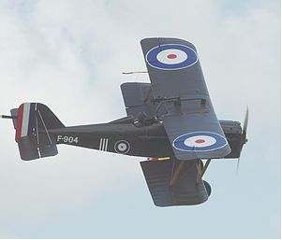

The SE 5 (The Spitfire of WW1), flown by Sixty in 191718

Between the wars, they were in India (actually, modern Pakistan, on the border with Afghanistan) and some of their activities hold such resonance with present-day issues that they make interesting revisiting Here are some examples

…….. During October 1927 there was some unrest amongst the Orakzal Afridis in the tribal salient north of Kohat because of fierce dissentions between the Sunni and Shia sects. To prevent the strife from spreading into open warfare, Sixty made a number of demonstration formation flights over the area. The trouble eventually petered out….

……… the campaign against the Faqir of Ipi, a self-proclaimed holy man, who in Autumn 1936 announced his adoption of the role of champion of Islam and declared a Jihad against the British. Initially he was successful in uniting tribes behind him and there was a fierce land battle on 26 November 1936. This last campaign drifted on until 1939, with the Faqir gradually losing support as the tribes split, until he had retreated to inaccessible caves in the mountains on the Afghan border). Sounds very reminiscent of recent times.

Lawrence of Arabia (in his alter ego of Aircraftsman Shaw) served on the Squadron in India and there are recollections of him which never been published before.

In December 1941, Sixty, by this time flying outdated Blenheim bombers, was thrown into the hopeless defence of Singapore. Suffering grievous casualties, they retreated northwards through Burma, finally regrouping in Lahore in 1942. The book mentions Westropp-Bennett, Bowden and Kingwill before this extract commences, as part of the history. I don’t need to say any more. Read it – it speaks for itself:

‘By 1942 virtually all of the aircrew had been killed or taken prisoner. In 2002, Jennifer Hughes, whose grandfather, Alun Hughes, served, she believes, on Sixty sent them a piece of verse inspired by a Reunion in Lahore, in her grandfather's handwriting, though the family thinks it unlikely that he wrote it.

60 Squadron at Lahore, the year is '42;
The number is the same one, but all the rest is new.
There are only ghosts, and shadows, faint echoes, little sign
Of the 60 in Ambala, in 1939

Reunion dinner at Lahore is just a fleeting wave.
The real reunion we would know is had beyond the grave.
Forgive us, you who come now, if we forbear to cheer.
It's not a want of welcome, but in our hearts a tear.
For those who were "old 60" and cannot now be here.

In the crewroom back at Mingaladon, when we were feeling low
We'd seek out Johnny Johnstone, and from him would then flow
A happy stream of constant, ever sparkling wit
'Til we'd forget our Burma life, the ennui of it

Air Observer "Smudger" Smith, another cheerful bloke
Who always had a laugh at life, who always had a joke
His little black moustache, his grin, his real Fleet Air Arm walk
What do they know of Sixty, these new ones when they talk?

Do you remember Robert Henry Joseph ‘Lofty’ Pyle?
A man with muscles like a mule, a heart devoid of guile,
Simple and true, from Canada he came.
And they talk of Sixty as though it were the same

"Paddy" Westrop-Bennett who, in a tropic glare,
Would dream about a chicken farm he wanted back in Eire
The "Terror of the Tori Khel" we used to call him then.
And now he's gone, just one more we shall never see again.

"Charlie" Gill and "Cocker" Logan, Kingwill, Bowden too;
"Baby" Bowden is a prisoner if Tokyo news is true.
Jimmy Appleton, it seems, was drowned at Singapore.
All those were the Sixty that we shall see no more.

So passes — all this, is something new.
God call us by another name, in 1942

It may not be great poetry, but it is certainly genuine, expressive and heartfelt. It has never been published before – perhaps it should have been. The present Sixty Squadron would still like to know the author’s name. He must have been one of the survivors – probably aircrew – from 1939.

The post-war period commences with Sixty in Indonesia. The Squadron was flying the American P-47 Republic Thunderbolt at the time. Another quote:

Prior to the two atom bombs of 6th and 9th August 1945, Sixty had been due to take part in Operation 'Zipper', the Allied invasion of Malaya. No-one knew what he reaction of widespread Japanese forces in the Far East to the Emperor’s call to surrender would be. Their armies were far from home and there was then no access to the modern media that we now take for granted – they had probably not even seen newspapers, out in the field. They could have had no conception of the disasters that had overtaken Hiroshima and Nagasaki. It was decided therefore, that 'Zipper' would go ahead more or less as planned, and the invasion fleet left Bombay and Madras during the first week in September. The landings were unopposed at Penang, Port Dickson, Port Swettenham, Sumatra and Singapore, where Mountbatten held the Surrender Ceremony on 12th September 1945.

Sixty took off on the first leg of its flight from India to Malaya on 25th September. The aircraft were flown via Rangoon and landed at Kalanang near Port Swettenham on 2nd October. The flight was long and arduous and H A Barnes who had recently replaced Joseph as 'A' Flight Commander, graphically describes the last leg:

"This trip from Rangoon to Swettenham was quite an effort in itself. Three overload tanks were fitted to each aircraft, each of 150 gallons, and although only two of them were filled, the extra fuel weighed nearly a ton. Some of the guns were loaded too, just in case. We were in sections of four and my section was the last to take off, by which time the cloud base was down to about 200 feet. There was no point in going back, because landing would be worse, and all we could do was to tuck into really tight formation of boxes of four with navigation lights on, and steam off across the Gulf of Martaban. Just before reaching the coast-line of the Malay peninsula, the cloud-base lifted a bit and we were able to climb out of it. All the way across the Gulf we were never able to make more than 200 feet because of the cloud-base. The route we took was that which we would have taken if 'Zipper' had taken place under operational conditions, and it took us over seven Japanese airstrips stacked to the perimeter tracks with fighters. The Thunderbolt wasn't really built for low-level stuff, and with overload tanks, handled rather like a pregnant hippopotamus. We were all profoundly grateful to Mr Rutherford for having split the atom in time."

Another extract from this time:

Squadron Leader W G G Duncan-Smith took command of Sixty at Sembawang on 14th July 1949.
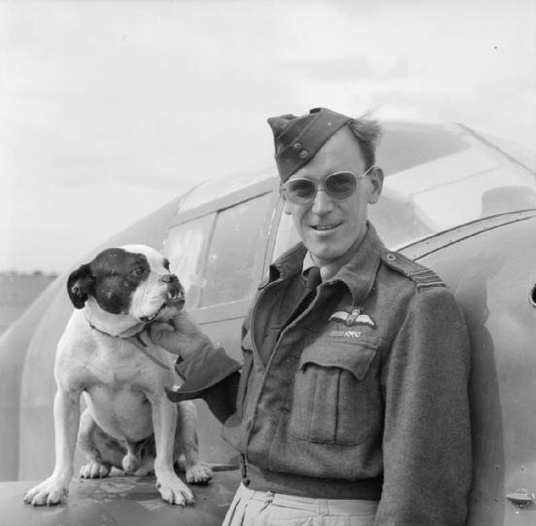
Wilfrid George Gerald Duncan-Smith was the father of the prominent Conservative politician, Iain Duncan Smith. Known to some as ‘Bill’, he was more usually just called Duncan, his mother’s maiden name. He had had an outstanding Second World War career, joining as an NCO pilot but rapidly commissioned. By 1941, as a flight commander, he was due for a rest but, still with the substantive rank of Pilot Officer, had had to stay, leading the squadron, whilst their new CO worked up to operational status. In January 1942, Duncan-Smith joined the Hornchurch Wing, now flying the improved Spitfire Mk IX and in March, whilst still a substantive Flying Officer, was promoted to acting Squadron Leader and given command of No 64 Squadron. Later he went to Malta, where he once spent six hours in the sea before being rescued, half-dead. The rescue boat was bombed and a bullet tore through his Mae West; he was astonished to have made it back to land. As an acting Group Captain, he later commanded 324 Wing RAF during its advance through Italy and southern France. Once several aircraft crashed whilst he managed to land safely and he was subsequently castigated. Many thought that this was unfair – he had briefed them correctly and either the weather was against them or they had been unlucky. However, he never said a word of complaint – he took the view that if an operation was successful, the commander took the credit even though it was the men who had done the work, and if it turned out less successful, it should be the commander who takes the blame, even if it was not his fault. Everyone who met him thought that he was a man of honour. It is said that women found him very attractive; he married a ballerina, Iain Duncan Smith’s mother. Contemporaries say that he was once propositioned by Marilyn Monroe during his time in America in the early 1950s. His son later commented drily: "I am told that nothing happened, but that's what my mother tells me, so I'm not quite certain.
Duncan Smith as a Squadron Leader

Later Sixty operated Javelins in the defence of Singapore and Malaysia against Indonesian aggression as part of the 'Confrontation' stand-off. This is a little-known period of history – the Army effort is quite well-covered – the RAF less so.

In 1969 the Squadron was re-formed, ostensibly as the RAF Germany light transport squadron, operating Pembrokes and Andovers until 1992, a fascinating period of Cold War history. Much of this part of the book will be genuinely revelatory about previously secret material. During the Cold War operations in Germany, the Pembroke and Andover transport role was largely a cover for Sixty's genuine task - photography of Soviet and East German military forces in and around the Berlin Air Corridors and the Berlin Control Zone. During this period, after the Gary Powers incident showed that direct overflight of the Soviet Union was now impossible but before the advent of readily available satellite imagery, the Corridor operations were the only source of aerial photographic intelligence to the West. Some of Sixty's intelligence provided vital warning to the West about Soviet intentions and timing of invasion during Dubcek's 'Prague Spring' uprising of 1968 and Jaruzelski's suppression of the Polish Solidarity movement in 1981. This episode is only just now becoming de-classified. Sixty was unique as the only RAF squadron specifically with this role, so there will be no other squadron history like it.
From 1993, Sixty was a Wessex helicopter squadron until 1997 when it was re-formed as an advanced helicopter training squadron at RAF Shawbury, where it continues to operate the Griffin. One of its better-known recent graduates was HRH Prince William.

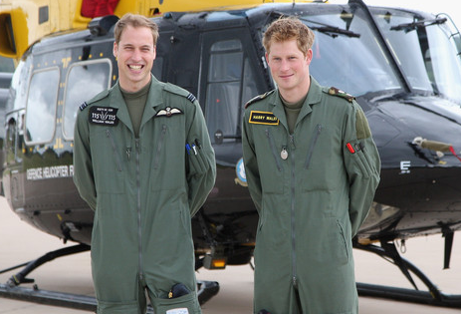
Flight Lieutenant William Wales joined Sixty as a student in Spring 2009 and clearly, there was a lot of Press interest. However Sixty took it calmly, simply saying that he participated fully in Squadron life and completed the course in the same manner as any junior officer would. The graduation ceremony took place on 15 January 2010 and the Reviewing Officer for the Wings Parade was HRH The Prince of Wales, accompanied by HRH The Duchess of Cornwall.
Two well-known brothers pose in front of a Sixty Squadron Griffin at RAF Shawbury on 18 June 2009

